# Tutorial

## Activity 1: Writing copy for your first web page

In the lab this week, you will be forking and cloning a starting repo which contains very basic HTML5 web page templates, one which you will modify with some information about yourself.

Some things to think about:

* How do you use the internet? Ans: I use the internet to connect with friends and people with same interests as me. I also use it for education and entertainment purpose
* What websites do you visit? (NB: "family friendly" !) Ans: Youtube, Facebook, Twitter, reddit
* Have you any programming or web design experience? Ans: I have some programming experience in Python, and C++, VB
* Do you see yourself as a programmer or designer, or both? Ans: I see myself as a in between with a bit more of designer
* What has brought you to this course at RMIT? Ans: It is one of my core courses
* What are you hoping to get out of the course? Ans: In depth knowledge of how a website work and how to create it
* What are your interests or hobbies? Ans: I like to play video game, cooking, food and music

Work with one or two friends to flesh out your copy.

This activity is to get to know your classmates and yourself a little better. By the end of this exercise you should have some idea of what to put in your personal webpage.

For administrative reasons, there will be a few other fields to fill in (name, student number, a personal photo). This will help the entire web programming team get to know you better and more importantly know how to pitch answers to your questions.

## 

## 

## Activity 2: Examine the Elements of a Webpage

Have a look at the following webpage: <http://www.w3schools.com/html/html_intro.asp>. The top and bottom of the page is shown with a red bar separating the two sections. *If you have a laptop please have a look at the live version*.

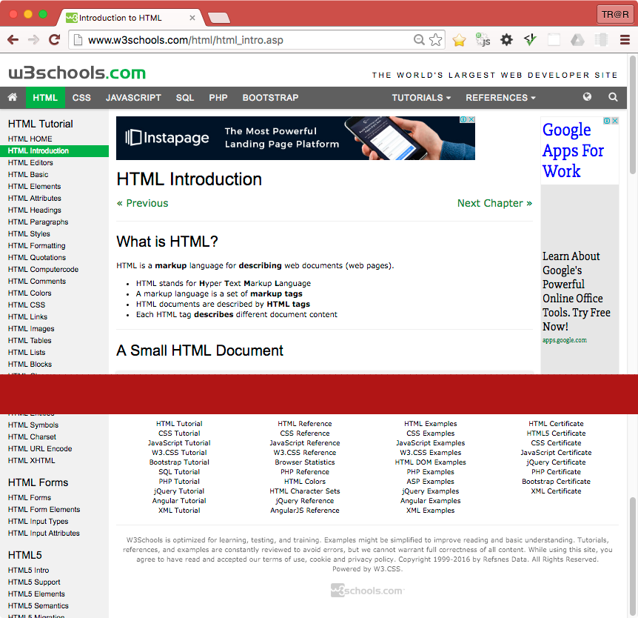



* On the webpage above, identify the following web elements:
  + Headings (eg <h1>...</h1>, <h2>...</h2>, … , <h6>...</h6>),
  + Paragraphs (<p></p>),
  + Anchors or Hyperlinks (<a href="...">...</a>),
  + Images (<img src="..." alt="..."/>) and other multimedia.

Ans: Draw on the picture

* Identify styling such as **bold** and **italic** text. We will cover shading and colouring next week.

Ans: Draw on picture

* What is the difference between an **unordered list** (<ul>) and **list items** (<li>). Can you see examples of each on the webpage above?

Ans: Unordered list <ul> is a tag that contain the list item <li> inside. You only need 1 pair of <ul> tag, at the begin and the end of the list. You need to declare <li> every time you list an item in your list.

* Does this website use modern HTML5 Contextual Elements? (eg <header>, <nav>, <main>, <footer>, <aside>). Identify which areas should be grouped into these elements.

Ans: Yes, the website use <header> tag.

<header> should be used to group elements like the title of the website, meta tag, icon or the headers.

<nav> should be used to group block of elements with hyperlinks like navigation bar.

<main> should be used to group the main elements of the websites like headers, paragraph, article, etc.

<footer>should be used to group element about the document like author of the document, contacts, links to other pages, copyrights, etc.

<aside>should be used to group element that are somewhat related to the main document.

* How many navigation elements are there? If more than one, why are there more than one?

Ans: There are about 444 navigation elements in that webpage. The navigation elements help the user to navigate ( or go to) specific part of the web site easier and the author can use nav elements to help explain his/her article better. Moreover, it helps link all the webpage of the website together and help with SEO.

## 

## 

## Activity 3: Evolution of the HTML standard

What page elements were present in the very first versions of HTML? What form did the first web documents take?

Ans: The elements present in the first version of HTML are: HEADER, BODY, Heading 1-6, paragraph, OL, UL, DL, DT, Anchor. The first web page was a document with hyperlink integrated into the text that link to other pages.

HTML3 and HTML4 standards were developed at a time that was seen as being very chaotic. Name some reasons for why this was and state what new elements we saw introduced at this time.

Ans: There were too many competitions in web browser market at that time and there is no standard way to develop a website that work on all of the available browsers. Moreover, the developers did not follow the rules set by W3C.

HTML3: introduced lots of attributes and tags to control the style (font, size, color, border, alignment) of the document so it was hard for user to remember. It also created some tags that are still used till now like <img> and <table>.

HTML4: separate style manipulation attributes from content.

The XHTML standard is described as being very strict, quite unlike HTML3 and 4. What rules did XHTML impose on developers? Think in terms of:

* Tags: closing and nesting them in correct sequence.
* Use of uppercase and lowercase characters.
* Separation of style and content

How did these changes allow XHTML documents to be more accessible across a wider range of devices: eg PC's, early WAP enabled mobile phones, screen readers for the visually impaired etc.

Ans:

* All tags must be in lower case.
* All tags must be closed. (e.g. <p>… <\p>)
* Tags must be nested correctly (e.g. <strong><em>…<\em><\strong>)
* Attributes must be in quotes (e.g. <table height = “100%”>)
* Attributes need a value
* The opening <html> tag was longer and more complicated e.g.

<?xml version = “1.0”?>

<!DOCTYPE html PUBLIC”-//W3C//DTD XHTML 1.0 Strict ” >

<html xmlns = “ link of the website“ lang = “en” xml:lang = ”en”>

Because of the stricter syntax, XHTML forces developer to follow the syntax precisely or it will not work, making it a standard and compatible with most browser.

In contrast to HTML, which sometimes allows small errors to slip through, XHTML doesn’t allow badly form code making more accessible across wider range of small/big devices as sometimes small devices cannot run if the code is badly written

HTML5 introduced many new elements and attributes. Think in terms of:

* Simpler doctype declaration.
* New tags, including standard multimedia tags (audio/visual).
* New form inputs, validation of form data using html markup, not code/scripting
* Semantic Web elements

Discuss the benefits and improvements contained in the HTML5 standard.

Ans: HTML5 is a improvement of HTML4, bringing back some of simpler rules and syntax in the previous version like:

* Simpler doctype making it easier and faster for developer to code
* Introduce new tags that support multimedia like audio/ video, HTML5 doesn’t depend on third party plug-in to use this type of file. Or able to use canvas or svg file.
* Revision for some tag like <meta> tag for more suitable for search engine to recognize the website.
* Sematic tags that help search engines analyze page content and rank website. i.e. <head> contain <meta> tags, <nav>, <main>
* HTML5 support JavaScript.
* New input types and attributes that help developing and manipulating a website easier e.g. mail, date, time etc.

Finally, HTML5 has brought back many (but not all) of HTML4's more relaxed coding rules. What are they and why are the strict XML syntax rules of XHTML no longer needed today?

Ans:

* Empty tags don’t need a closing slash e.g. <br>
* Values like integer don’t need quotation mark e.g. value =1
* Uses lowercase for tags
* XML syntax rules of XHTML no longer needed today because HTML has already became the standard in the industry with easier and simpler to remember syntax rules.